In a binary tree, a **lonely** node is a node that is the only child of its parent node. The root of the tree is not lonely because it does not have a parent node.

Given the root of a binary tree, return *an array containing the values of all lonely nodes* in the tree. Return the list **in any order**.

**Example 1:**

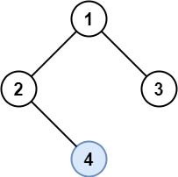

**Input:** root = [1,2,3,null,4]

**Output:** [4]

**Explanation:** Light blue node is the only lonely node.

Node 1 is the root and is not lonely.

Nodes 2 and 3 have the same parent and are not lonely.

**Example 2:**

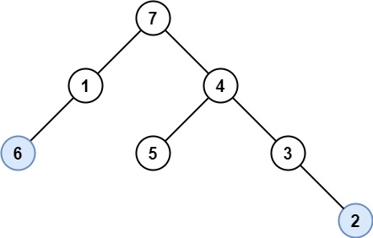

**Input:** root = [7,1,4,6,null,5,3,null,null,null,null,null,2]

**Output:** [6,2]

**Explanation:** Light blue nodes are lonely nodes.

Please remember that order doesn't matter, [2,6] is also an acceptable answer.

**Example 3:**

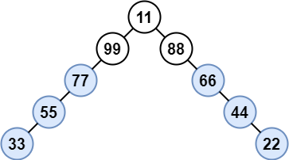

**Input:** root = [11,99,88,77,null,null,66,55,null,null,44,33,null,null,22]

**Output:** [77,55,33,66,44,22]

**Explanation:** Nodes 99 and 88 share the same parent. Node 11 is the root.

All other nodes are lonely.

**Example 4:**

**Input:** root = [197]

**Output:** []

**Example 5:**

**Input:** root = [31,null,78,null,28]

**Output:** [78,28]

**Constraints:**

* The number of nodes in the tree is in the range [1, 1000].
* Each node's value is between [1, 10^6].